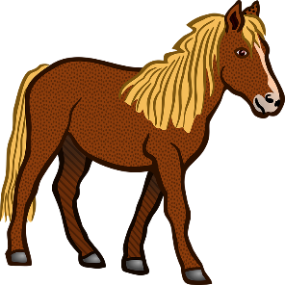
Horse Eats/Drinks

Indian Rice Grass
Wheat Grass
Water

*Must pass all hurdles in order to finish relay! If items on your card are not available, your turn ends.
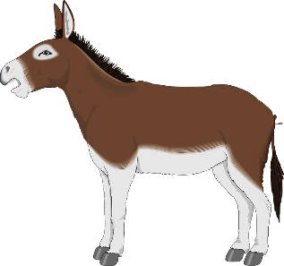
Mule Eats/Drinks

Indian Rice Grass
Wild Rye
Water

*Must pass all hurdles in order to finish relay! If items on your card are not available, your turn ends.
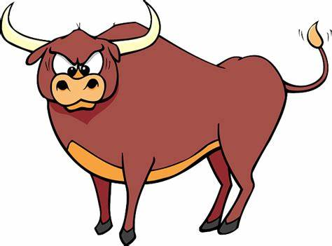
Ox Eats/Drinks

Indian Rice Grass
Wheat Grass
Wild Rye
Water

*Must pass all hurdles in order to finish relay! If items on your card are not available, your turn ends

Indian rice grass | Indian rice grass
Indian rice grass | Wheat grass
Wheat grass | Wheat grass
Wheat grass | Wild rye
Wild rye | Wild rye
Water | Water
Water | Water
Rattlesnake | Rattlesnake

